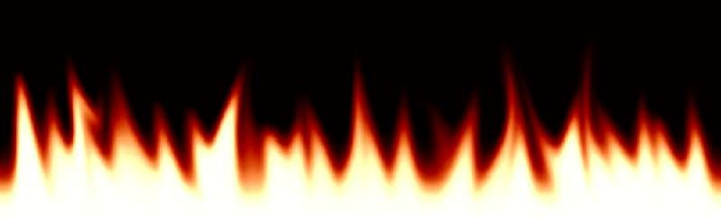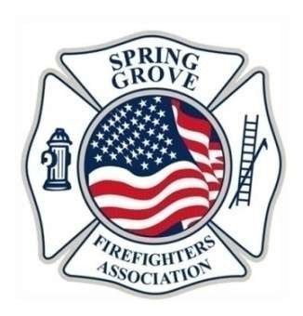

“Good Food, Good Times”

Saturday, August 13, 2016
5:30pm – 11:00pm
at Horse Fair Park
8105 Blivin Street, Spring Grove, IL 60081
LIVE DJ PLAYING ALL NIGHT!
Steak or chicken with sides of baked potato, coleslaw, Stade’s sweet corn, roll, and dessert. Adult beverages and children’s hot dog meals will also be served.

All proceeds benefit the Spring Grove Firefighters Association

